 Menoufia University 
Faculty of Electronic Engineering
Department of Computer science & Engineering


Smart Irrigation System

Supervised by
Prof. Abdalla Nabil Mohamed Moustafa

Team members
- Ola Magdy Mortada El-Shiekh
- Rana Emad Mohamed El-Said
- Youssef Mohamed Meshref Mohamed
- Mostafa Mahmoud Shoulkamy Abd-Ellatif
- Mostafa Kotb Goda Mohamed
- Mohamed Shaban Hassan Radwan
- Hamada Saied Mohamed Azoz

ACKNOWLEDGMENTS

We would like to express our gratitude to Prof. Dr Abdalla Nabil Mohamed Moustafa for his great engagement and guidance. We owe many thanks to him for his great effort in directing the program systems, Control and Robotics during our graduation year. We would also like to extend our thanks to all teaching staff members in our departments, and we would like to extend our thanks to everyone who supported and helped us all the way during this project been implemented. We really appreciate and are grateful for what they have done. It was their kindness that gave us the opportunity to successfully complete the project.

Table OF Contents
Introduction......................................................................................................................6
- Smart Irrigation System
- Hardware component that used
- Mobile Application
- Artificial Intelligence model
1. Smart Irrigation System...................................................................................... 10
1.1 Introduction
1.2 Hardware Components
    - Microcontroller Unit (MCU): AVR Atmega32
    - Soil Moisture Sensor
    - LM35 IC temperature sensor
    - DS18B20 Temperature Sensor
    - SIM800L 5V GPRS GSM Module + Antenna
    - Project prototype
1.3 software codes
2. Mobile application and System Control................................................... 42
  - Fluter Platform for App Development
    - introduction
    - Features
    - UI/UX
    - Authentication and Privacy
    - What Does Firebase Do?

Major Uses In Application
    - Analysis
    - Remote config
    - Cloud messaging
    - Data base
    - authentication

3. Artificial Intelligence for Irrigation Control........................................... 72
  - Object detection
    - Definition
    - Background
    - Python code of face detection
    - Theory
    - Object detection application
  - Object recognition
    - Definition
    - Face recognition
    - Advantages of face recognition security
    - Using face recognition with car
    - Materials that used
    - Face database
4. Overview of Smart Irrigation System ........................................................... 105
4.1 What is meant by Smart
4.2 Features
4.3 What do we do for Water Conservation Efficiency?
4.4 Smart Irrigation System benefits
4.5 In the Future

Chapter 2
Mobile application and System Control

2.1 Flutter and Firebase

2.1.1. Introduction Flutter
Flutter is an open-source UI software development kit (SDK) created by Google. It is used to develop natively compiled applications for mobile, web, and desktop from a single codebase. Launched in May 2017, Flutter has rapidly gained popularity among developers due to its ease of use, rich set of pre-designed widgets, and powerful performance.

How Flutter Works
Architecture: Flutter consists of three key architectural layers:
  - Framework: Written in Dart, the framework provides a rich set of platform, layout, and foundation libraries.
  - Engine: The engine, primarily written in C++, provides low-level rendering support using the Skia graphics library.
  - Embedder: This layer enables Flutter to run on different platforms by providing platform-specific integrations.
Rendering: Flutter uses a rendering engine that builds and displays the UI. The engine converts the widget tree (created by the framework) into actual pixels on the screen using Skia.
Widgets and Layout: Widgets are the core building blocks of a Flutter app. They describe what their view should look like, given their current configuration and state. The layout system arranges these widgets into the final UI.

2.1.2. Introduction Firebase
Firebase is a comprehensive platform developed by Google for building web and mobile applications. It offers a suite of cloud-based services that simplify app development, providing tools and infrastructure to help developers build high-quality apps quickly. Firebase is designed to help developers manage their backend infrastructure, enhance app functionality, and improve user engagement with minimal effort.

Benefits of Using Firebase
Ease of Integration:
Firebase SDKs are easy to integrate into your app, with extensive documentation and support for multiple platforms including iOS, Android, and web.
Real-Time Capabilities:
Both Firestore and Realtime Database provide real-time data synchronization, which is essential for collaborative and dynamic apps.
Scalability:
Firebase services are designed to scale automatically with your app, handling growing user bases and increasing data loads seamlessly.

Security:
Firebase Authentication ensures secure user login, and Firebase Security Rules enforce data access controls to keep your data safe.
Analytics and Monitoring:
Comprehensive analytics and performance monitoring tools help you track user behavior, monitor app health, and make data-driven decisions.
Cost-Effective:
Many Firebase services are available for free or offer a generous free tier, with pay-as-you-go pricing that scales with your app.

Use Cases for Firebase
Social Networking Apps:
Real-time updates, user authentication, and media storage.
E-commerce Apps:
Inventory management, real-time chat support, and transaction processing.
Collaborative Tools:
Document editing, project management, and real-time data synchronization.

2.1.3 Feature Flutter and Firebase

Features of Flutter
Single Codebase:
Write once, run on multiple platforms including iOS, Android, web, and desktop.
Hot Reload:
Allows real-time updates without restarting the app, enabling faster development and debugging.
Rich Set of Widgets:
Provides a comprehensive library of pre-designed widgets that adhere to both Material Design and Cupertino design standards.
High Performance:
Uses the Skia graphics library and Dart’s ahead-of-time (AOT) compilation to ensure smooth and fast performance.
Customizable UI:
Highly flexible and customizable widgets that can be combined and modified to create unique UIs.
Open Source:
Flutter is open source, with a large and active community contributing to its growth and improvement.
Dart Language:
Utilizes Dart, which is easy to learn and offers modern language features like strong typing, async-await, and a rich standard library.
Declarative UI:
The declarative approach to UI design makes the code more readable and maintainable.

Cross-Platform Development:
Supports building applications for various platforms, reducing development time and cost.
Strong Ecosystem:
Extensive set of plugins and packages available via pub.dev for extending functionality.

Features of Flutter with Firebase
Authentication:
Integrate various authentication methods including email/password, Google, Facebook, and more.
Firestore Database:
Real-time NoSQL cloud database that allows seamless data synchronization across all clients in real-time.
Firebase Realtime Database:
A NoSQL cloud database that supports data synchronization in real-time.
Cloud Storage:
Store and serve user-generated content like photos and videos with Firebase Storage.
Cloud Functions:
Run backend code in response to events triggered by Firebase features and HTTPS requests without managing servers.
Firebase Hosting:
Fast and secure web hosting for static and dynamic content.
Crashlytics:
Real-time crash reporting and analytics to help improve app stability.
Analytics
Google Analytics for Firebase offers unlimited reporting on up to 500 distinct events.
Remote Config:
Dynamically change the behavior and appearance of your app without publishing an app update.
Cloud Messaging (FCM):
Send notifications and messages to engage users across platforms.
Performance Monitoring:
Gain insight into the performance characteristics of your app with real-time monitoring.
Firebase In-App Messaging:
Engage active app users by sending targeted, contextual messages that nudge them to complete key in-app actions.

Combining Flutter with Firebase
When you combine Flutter with Firebase, you get a robust and scalable backend with a powerful and flexible frontend framework. This combination provides:
Seamless Integration:
Firebase plugins are available for Flutter, making it easy to integrate Firebase services.
Real-Time Data Sync:
Use Firestore or Realtime Database for real-time data updates, which is crucial for applications like chat apps, live updates, and collaborative tools.
Scalability:
Firebase services can scale with your app, handling increased traffic and larger datasets.
Security:
Firebase Authentication and Firebase Security Rules ensure that your app's data is secure and accessible only to authorized users.

Backend as a Service (BaaS):
Firebase provides a complete backend solution, including databases, authentication, cloud functions, and more, allowing developers to focus on building the frontend with Flutter.
Efficient Development:
Both Flutter and Firebase emphasize developer productivity, enabling rapid prototyping, iterative development, and faster time to market.

2.1.4 UI/UX
Flutter is a UI toolkit developed by Google for building natively compiled applications for mobile, web, and desktop from a single codebase. It offers a rich set of tools and features specifically designed to help developers create visually appealing and highly performant user interfaces. Here’s a comprehensive overview of Flutter’s tools for UI/UX development:

Core Tools and Features
Flutter Widgets:
  - StatelessWidget and StatefulWidget: The fundamental building blocks of Flutter apps. StatelessWidget is immutable, while StatefulWidget can change its state during the app's lifetime.
  - Material Components: A comprehensive set of widgets following Google's Material Design guidelines, including buttons, cards, lists, and more.
  - Cupertino Widgets: iOS-style widgets that provide a native look and feel on iOS devices, such as navigation bars, sliders, and switches.
Layouts:
  - Flex: Manages flexible layouts using Row, Column, and Flex.
  - Stack: Allows for overlaying widgets on top of each other.
  - GridView: Creates grid-based layouts for displaying items in a grid.
Styling and Theming:
  - Themes: Define a consistent style for your app using ThemeData for Material apps and CupertinoThemeData for Cupertino apps.
  - CustomPainter: Allows for creating custom graphics and painting directly on the canvas.
Animations:
  - Implicit Animations: Simple animations with widgets like AnimatedContainer, AnimatedOpacity, and more.
  - Explicit Animations: Advanced animations using AnimationController and Tween for fine-grained control.
  - Hero Animations: Seamlessly transition between two screens with shared elements.
  - Animations Package: Provides pre-built, complex animations to enhance your app's UI.
Gestures:
  - GestureDetector: Detects various gestures such as taps, swipes, and drags.
  - Draggable and DragTarget: Enables drag-and-drop interactions within your app.

Navigation and Routing:
  - Navigator: Manages a stack of pages to enable in-app navigation.
  - PageRoute: Various types of route transitions like MaterialPageRoute and CupertinoPageRoute.
  - Routing Package: Advanced routing mechanisms, including nested navigation and dynamic routing.
Form Controls:
  - Form and FormField: Create and manage forms with validation.
  - TextField: Input field for accepting text input.
  - DropdownButton, Checkbox, Radio: Various form controls for user input.
Media and Graphics:
  - Image: Display images from assets, network, or file system.
  - VideoPlayer: Play videos within your app.
  - Canvas and CustomPainter: Draw custom graphics and shapes.
Internationalization (i18n) and Localization (l10n):
  - intl Package: Support for internationalization, allowing your app to adapt to different languages and regions.
  - Flutter Localizations: Built-in support for localization with easy setup.

Accessibility:
  - Semantics: Provide accessibility information to assistive technologies.
  - Focus and FocusScope: Manage focus for keyboard and accessibility navigation.
Plugins and Packages:
  - Flutter Plugins: Access native device features like camera, GPS, and sensors.
  - Third-Party Packages: A rich ecosystem of community-contributed packages available on pub.dev.

Tools for Development
Flutter DevTools:
A suite of performance and debugging tools, including a widget inspector, timeline view, memory profiler, and network profiler.
Hot Reload and Hot Restart:
  - Hot Reload: Instantly reflects changes in the code without restarting the app.
  - Hot Restart: Restarts the app but preserves the app state for faster development cycles.
Flutter Inspector:
A powerful tool for visualizing and exploring the widget tree and diagnosing layout issues.
Dart DevTools:
Tools for profiling, debugging, and inspecting Dart code, including source-level debugging and performance monitoring.

2.1 Major Uses In Application

2.1.1. Authentication
Firebase Authentication in a Flutter app, allowing users to sign in and register using their email and password.

Step to configuration authentication
- Create project in Firebase and initialize Firebase in flutter code
- Sign_up

* Use to create new account for users by using Email and password

* Code
Future<void> signUpWithEmail(String email, String password, BuildContext context) async {
try {
await FirebaseAuth.instance.createUserWithEmailAndPassword(email: email, password: password).
then((value) {
Navigator.of(context).pushReplacementNamed('/Home');
});
} catch (e) {
if (e is FirebaseAuthException) {
if (e.code == 'email-already-in-use') {
ScaffoldMessenger.of(context).showSnackBar(const SnackBar(content: Text('This email is already in use')));
} else {
print('FirebaseAuthException: ${e.message}');
ScaffoldMessenger.of(context).showSnackBar(const SnackBar(content: Text('This email is already in use')));
}
} else {
print('Unknown error: $e');
ScaffoldMessenger.of(context).showSnackBar(const SnackBar(content: Text('An unknown error occurred')));
}
}
}

*Screen



- Sign_in

* Use to check in user has already account or not and navigate to home page

* Code
Future<void> signInWithEmail(String email, String password, BuildContext context) async {
try {
await FirebaseAuth.instance.signInWithEmailAndPassword(email: email, password: password)
.then((value) {
Navigator.of(context).pushReplacementNamed('/Home');
});
} catch (e) {
if (e is FirebaseAuthException) {
if (e.code == 'user-not-found') {
ScaffoldMessenger.of(context).showSnackBar(const SnackBar(content: Text('User not found')));
} else if (e.code == 'wrong-password') {
ScaffoldMessenger.of(context).showSnackBar(const SnackBar(content: Text('Wrong password')));
} else {
print('FirebaseAuthException: ${e.message}');
ScaffoldMessenger.of(context).showSnackBar(const SnackBar(content: Text('user not found')));
}
} else {
print('Unknown error: $e');
ScaffoldMessenger.of(context).showSnackBar(const SnackBar(content: Text('An unknown error occurred')));
}
}
}

*Screen

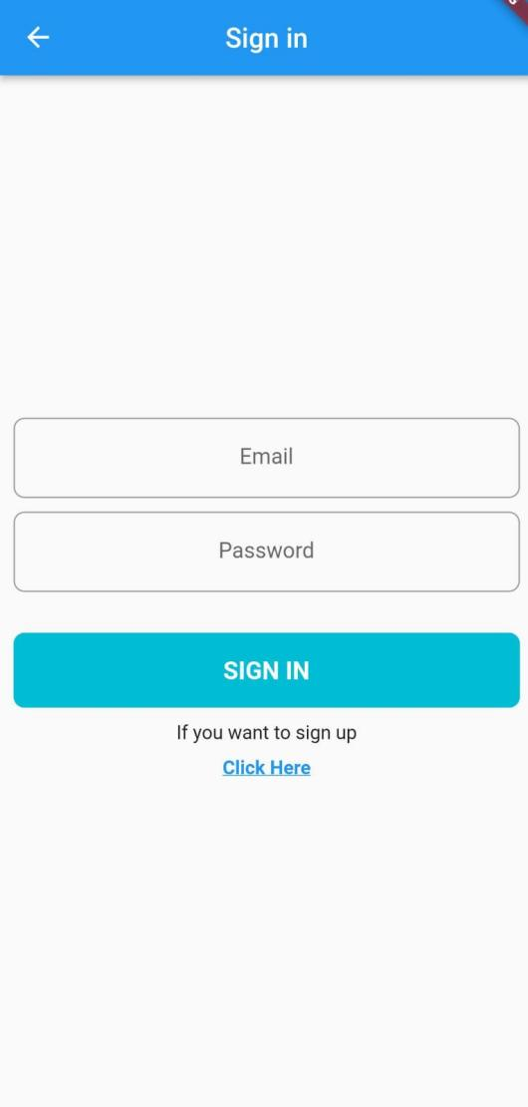

2.1.2. UNITS Data
Data of UNITS stored in FireStore . The role of Flutter to get data from FireStore to view UNIT data to user like (humidity ,temp ) to help him to make action

Code

StreamBuilder<QuerySnapshot>(
stream: FirebaseFirestore.instance
.collection('UNITS')
.where('UserEmail', isEqualTo: FirebaseAuth.instance.currentUser!.email)
.snapshots(),
builder: (BuildContext context, AsyncSnapshot<QuerySnapshot> snapshot) {
if (snapshot.hasError) {
return Center(
child: Text('Error in Database: ${snapshot.error}'),
);
}
if (snapshot.connectionState == ConnectionState.waiting) {
return const Center(
child: CircularProgressIndicator(),
);
}
List<Map<String, dynamic>> dataList = snapshot.data!.docs.map((DocumentSnapshot document) {
return document.data() as Map<String, dynamic>;
}).toList();

Screen
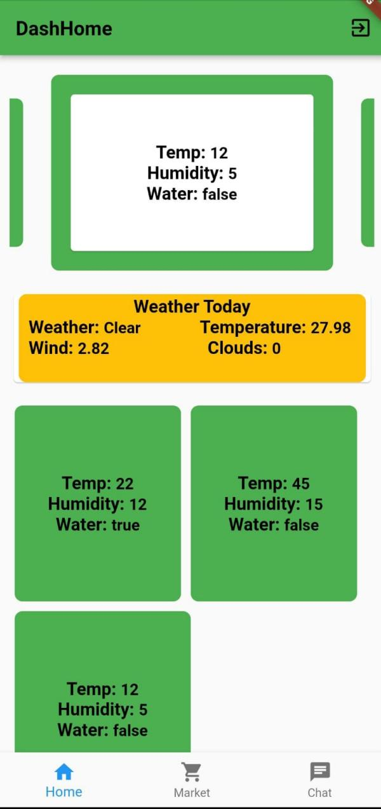

2.1.3. Weather API

- Use ApI Weather from weatherapi.com
https://api.openweathermap.org/data/2.5/weather?q=${cityName}&lang=ar&appid=9b343d5451b274be22d513bac8c0303d
- Get permission GPS
var status = await Permission.location.request();
if (status == PermissionStatus.granted) {
Position position = await Geolocator.getCurrentPosition(
desiredAccuracy: LocationAccuracy.high);
List<Placemark> placemarks = await placemarkFromCoordinates(
position.latitude, position.longitude);
String governorate = placemarks.isNotEmpty
? placemarks[0].administrativeArea ?? 'Unknown'
: 'Unknown';

- use Getx Controller to handle get data from Api
class WeatherController extends GetxController {
Locations locations = Locations();
RxList<Weather> weather = <Weather>[].obs; // Initialize as RxList with .obs
var isLoading = false.obs;
WeatherApi _weatherApi = WeatherApi();
Future<void> getWeatherApi() async {
try {
isLoading(true);
await locations.updateCityName();
weather.assignAll(await _weatherApi.getWeatherApi(locations.cityName));
} catch (error) {
print('Error: $error');
} finally {
isLoading(false);
}
}
}

- View data to user 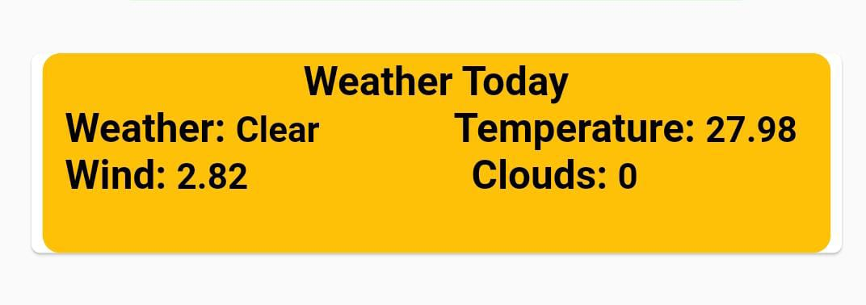

2.1.4. Market

2.1.5. Chat
We use chat if user wants to call experts to get some details about UNITS or any help
Configuration
- Make Collection (“chat”) in fireStore
- If user send message ,it create new document in FireStore Field ( CreatedAt, Text, From , To)
void _sendMessage() async {
try {
final user = FirebaseAuth.instance.currentUser;
final userIdentifier = user != null ? user.email ?? user.uid : null;
if(userIdentifier != null){
await FirebaseFirestore.instance.collection('Chat').add({
'Text': _textController.text,
'CreatedAt': Timestamp.now(),
'From': userIdentifier,
'To': 'Experts',
});
_textController.clear();
}else{
print('Error sending message: User not authenticated');
}
} catch (error) {
print('Error sending message: $error');
}
}

- View to user sorted by createdAt
StreamBuilder<List<QuerySnapshot>>(
stream: Rx.combineLatest2(
FirebaseFirestore.instance
.collection('Chat')
.orderBy('CreatedAt')
.where('From', isEqualTo: FirebaseAuth.instance.currentUser!.email)
.snapshots(),
FirebaseFirestore.instance
.collection('Chat')
.orderBy('CreatedAt')
.where('To', isEqualTo: FirebaseAuth.instance.currentUser!.email)
.snapshots(),
(QuerySnapshot a, QuerySnapshot b) => [a, b],
),
builder: (ctx, AsyncSnapshot<List<QuerySnapshot>> chatSnapshot) {
if (chatSnapshot.connectionState == ConnectionState.waiting) {
return Center(child: CircularProgressIndicator());
}
if (chatSnapshot.hasError) {
return Text('Error: ${chatSnapshot.error}');
}
final chatDocs = <QueryDocumentSnapshot>[];
chatSnapshot.data?.forEach((snapshot) {
chatDocs.addAll(snapshot.docs);
});
if (chatDocs.isEmpty) {
return Text('No Data');
}
// Sort the chatDocs by 'CreatedAt'
chatDocs.sort((a, b) => a['CreatedAt'].compareTo(b['CreatedAt']));
return ListView.builder(
itemCount: chatDocs.length,
itemBuilder: (ctx, index) {
final isCurrentUser = chatDocs[index]['From'] == FirebaseAuth.instance.currentUser!.email;
return ListTile(
title: Text(
chatDocs[index]['Text'],
textAlign: isCurrentUser ? TextAlign.right : TextAlign.left, // Align text based on the sender
),
subtitle: Text(
chatDocs[index]['From'].toString(),
textAlign: isCurrentUser ? TextAlign.right : TextAlign.left, // Align sender's name based on the sender
),
tileColor: isCurrentUser ? Colors.white : Colors.grey, // Example color
// Leading icon for messages from the current user
);
},
);
},
),
),

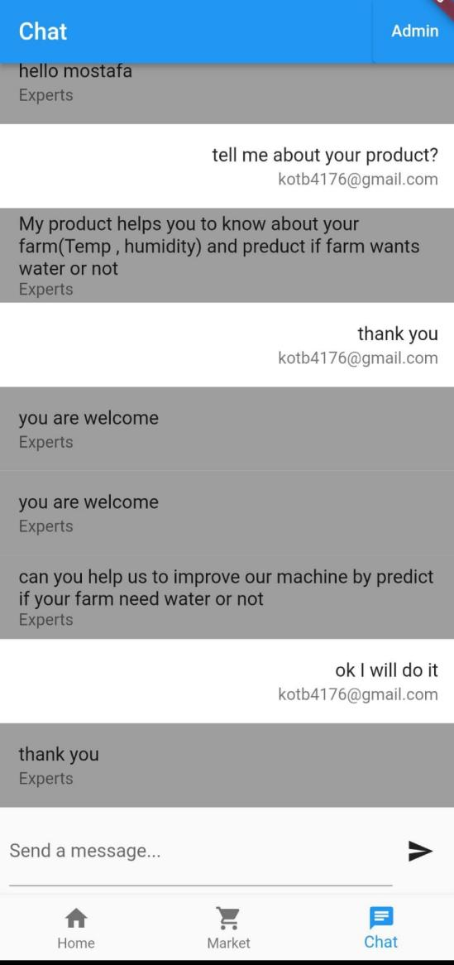

- There are another Application for Experts only to receive message from user and can identify user to send message to him

void _sendMessage() async {
try {
final user = FirebaseAuth.instance.currentUser;
final userIdentifier = user != null ? user.email ?? user.uid : null;
if(userIdentifier != null){
await FirebaseFirestore.instance.collection('Chat').add({
'Text': _textController.text,
'CreatedAt': Timestamp.now(),
'From': 'Experts',
'To': to.text,
});
_textController.clear();
to.clear();
}else{
print('Error sending message: User not authenticated');
}
} catch (error) {
print('Error sending message: $error');
}
}

